# Adding a User using the Program

## To Start - Background

* This document will show you how you can add a hunt to the database.
* For information on how to add players to the hunt, see the document “Making a User with the Program”.
* Admin Credentials are:
  + Email: [waltonca@etsu.edu](mailto:waltonca@etsu.edu)
  + Password: YMXH@9J!72kM6Em

### Steps

1. Run the program. You should be taken to this screen:

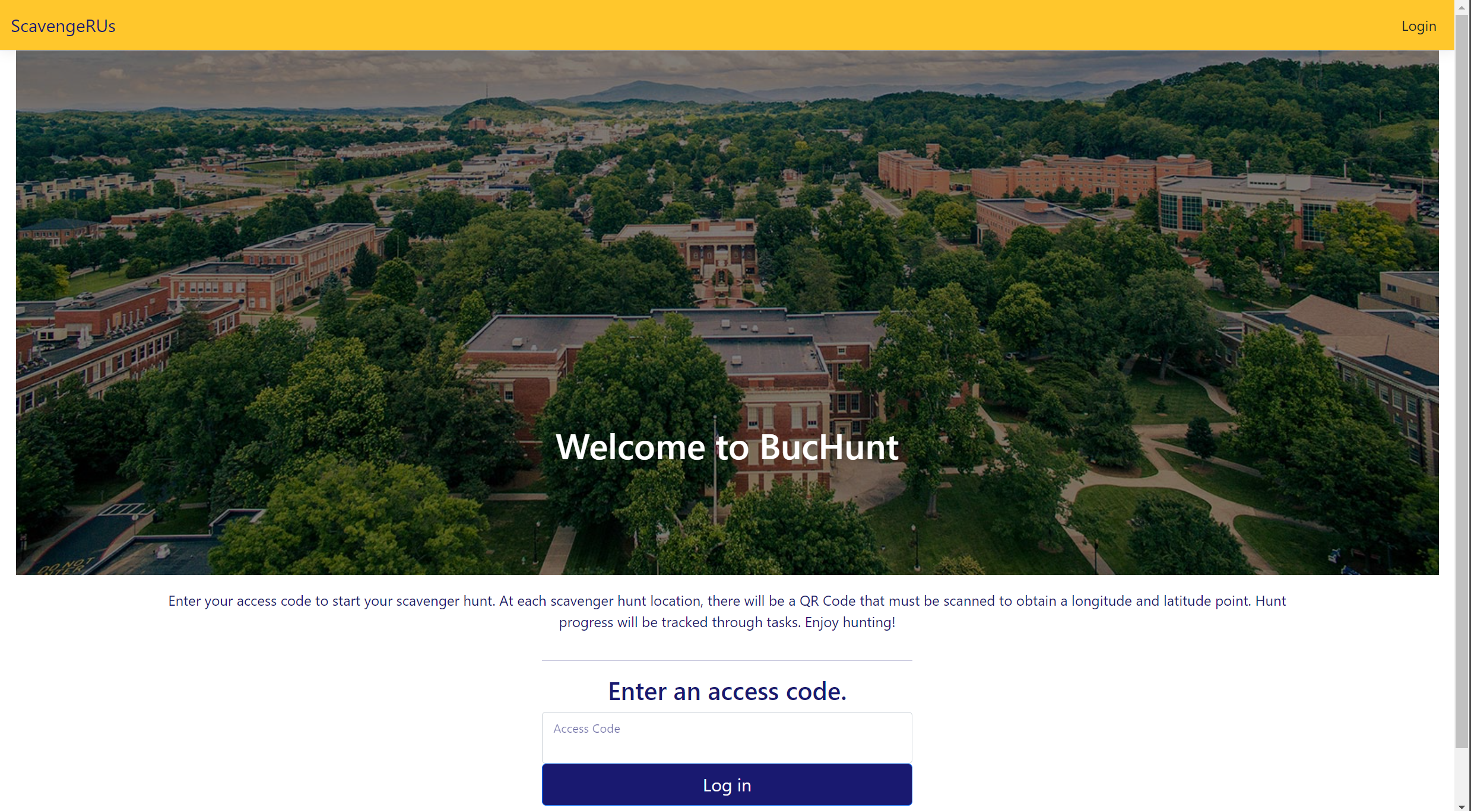

1. If you are logged in, logout (unless you are already logged in as an admin… then skip to Step 5). On the top-right of the screen, click “Log Out” to logout.
2. Then click “Login” after you’ve logged out. You should be taken to this screen:

1. The admin of this project’s credentials are:
   1. Email: [waltonca@etsu.edu](mailto:waltonca@etsu.edu)
   2. Password: YMXH@9J!72kM6Em
2. Press the “Log in” button after you enter the credentials above. You should be taken back to the BucHunt landing page:



1. Click on “Admin Portal” (highlighted in red above). You should be taken to the screen below:

1. Click on “Manage Hunts/Tasks”.

1. Click on “Create New Hunt”

1. Fill out the details of the hunt you want to create. When you’re done, your screen should look similar to this:

1. Click the “Create Hunt” Button.
2. Congratulations! The Hunt is Active!

### Adding Tasks to the Hunt